E-COMMERCE ORDER MANAGEMENT DATABASE SYSTEM

WEEK 3: SELLER AND INVENTORY MANAGEMENT SYSTEM

INVENTORY ANALYSIS

1. Total Products Available
This analysis is used to find the total number of products that are currently available in the inventory. It helps the administrator understand how many products are ready for sale.
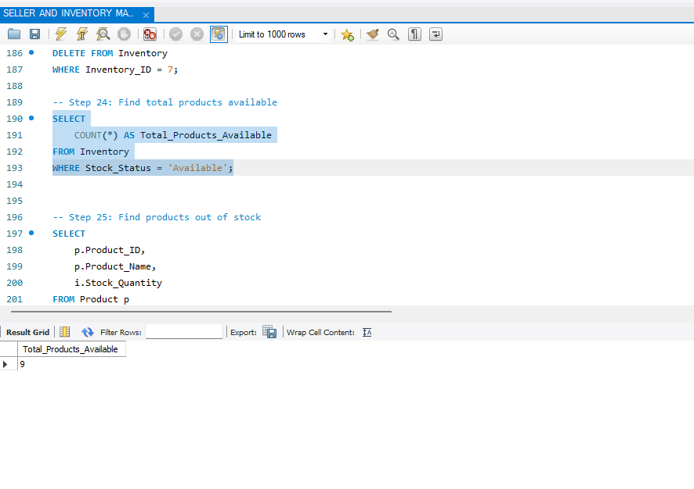

2. Products Out of Stock
This analysis is used to identify the products that currently have zero stock. It helps the administrator identify products that need to be restocked.
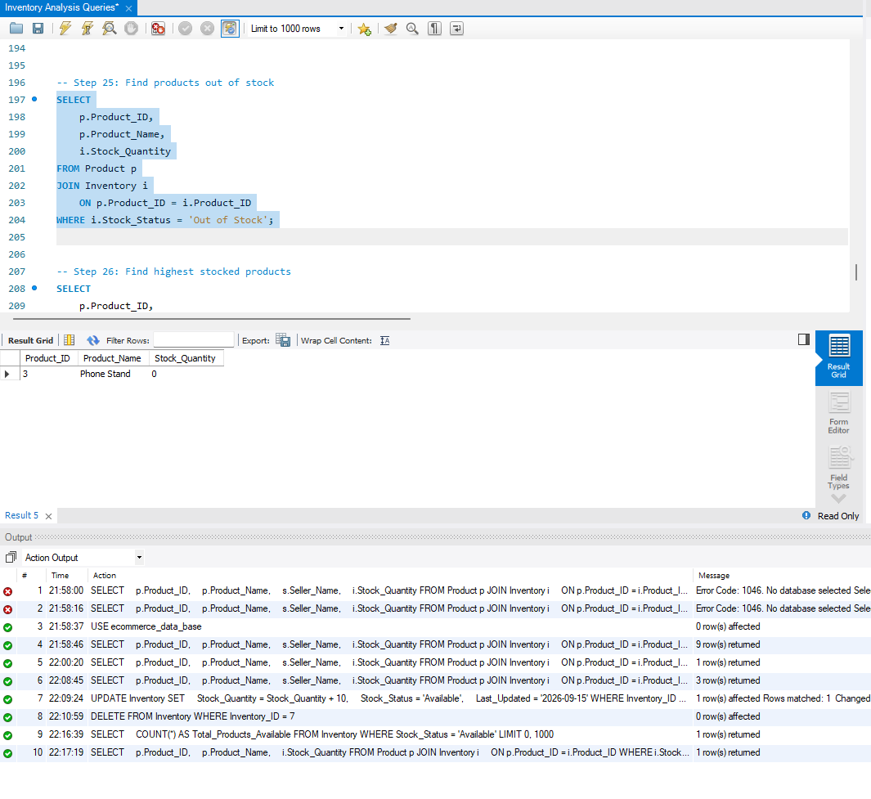

3. Highest Stocked Products
This analysis is used to identify the products with the highest stock quantity in the inventory. It helps in understanding which products have the largest available stock.
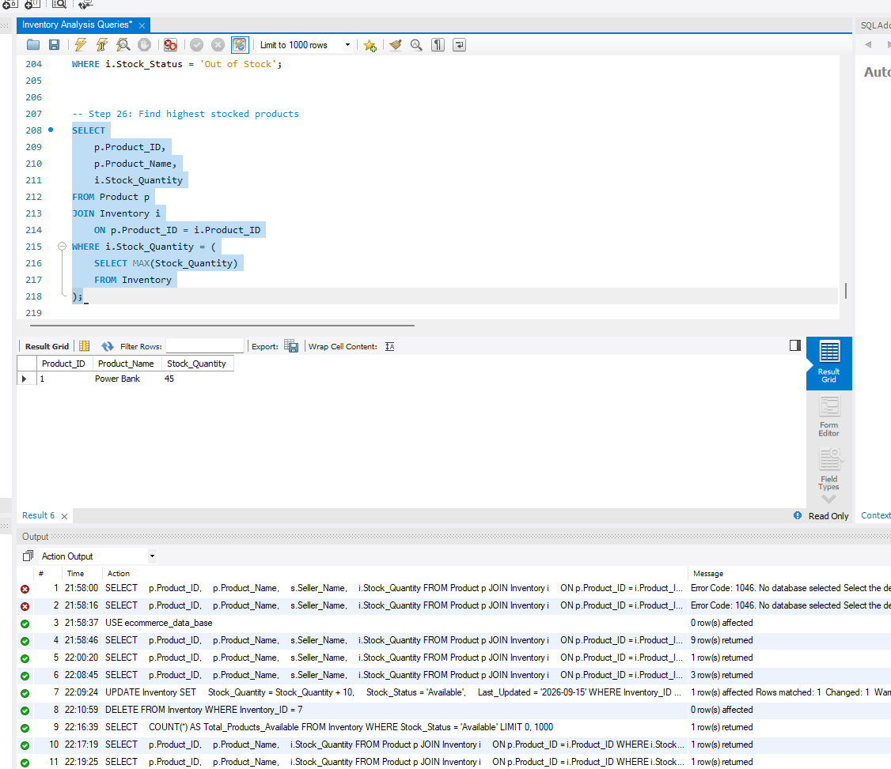

4. Average Inventory Quantity
This analysis is used to calculate the average quantity of products available in the inventory. It provides an overall view of the stock level maintained in the system.
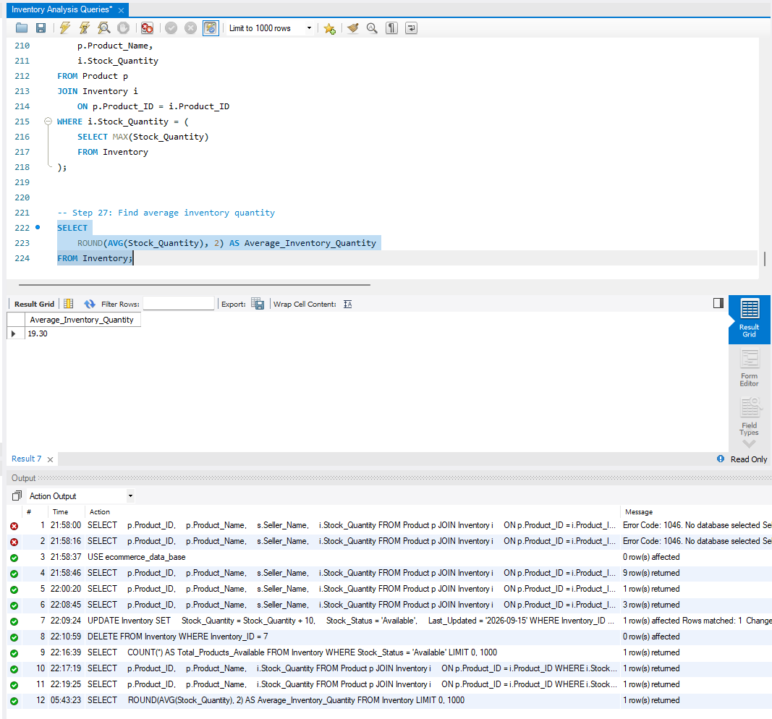

5. Inventory Analysis Summary
S.No | Analysis | Purpose
1 | Total Products Available | To find the number of products currently available
2 | Products Out of Stock | To identify products with zero stock
3 | Highest Stocked Products | To identify products with the maximum stock quantity
4 | Average Inventory Quantity | To find the average stock quantity

6. Conclusion
The inventory analysis provides useful information about the current stock condition of the system. It helps identify available products, out-of-stock products, highly stocked products, and the average inventory quantity. This analysis supports effective monitoring and management of inventory records.

